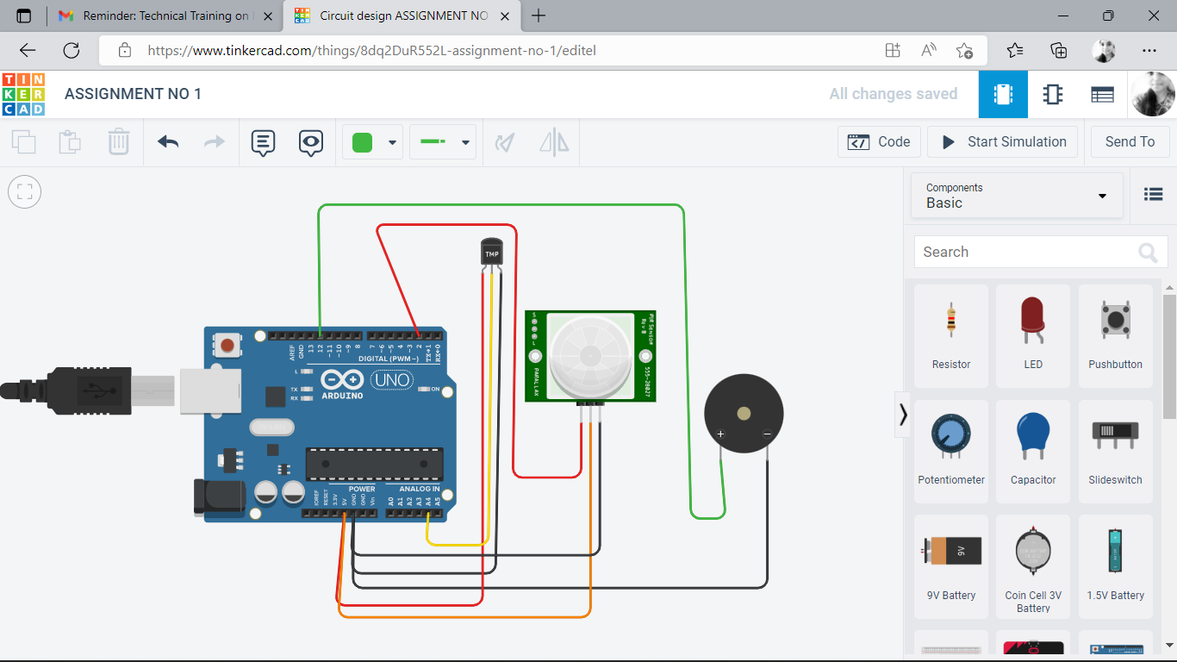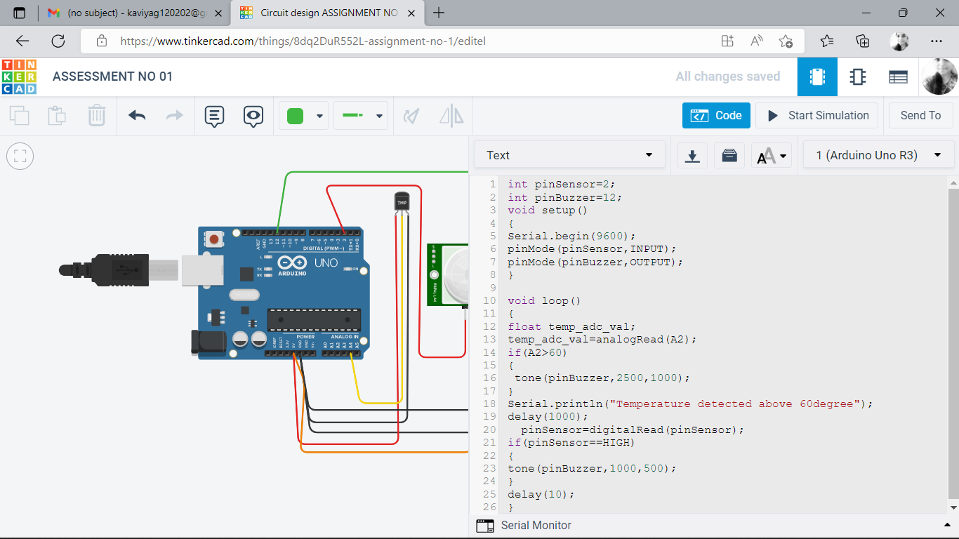

CODE:

int pinSensor=2;

int pinBuzzer=12;

void setup()

{

Serial.begin(9600);

pinMode(pinSensor,INPUT);

pinMode(pinBuzzer,OUTPUT);

}

void loop()

{

float temp_adc_val;

temp_adc_val=analogRead(A2);

if(A2>60)

{

tone(pinBuzzer,2500,1000);

}

Serial.println("Temperature detected above 60degree");

delay(1000);

pinSensor=digitalRead(pinSensor);

if(pinSensor==HIGH)

{

tone(pinBuzzer,1000,500);

}

delay(10);

}

OUTPUT:

